Scientific Goat Farming In Andaman & Nicobar Islands
Jai Sunder¹, A. Kundu² and M.S.Kundu³
^{1&3} Principal Scientist, ²Head, Division of Animal Science
ICAR-Central Islands Aagricultural Research Institue, Port Blair, A & N Islands
E-mail : jaisunder@rediffmail.com

Goats (Capra hircus) were probably one of the first of the ruminants to be domesticated; they are valued for milk, meat and mohair. Goat is a multi functional animal and plays a significant role in the economy and nutrition of landless, small and marginal farmers in the country. India with 135 million goats is one of the largest goats owning country in the world and playing a significant role in livelihood and nutritional security as well as providing supplementary income to nearly 70 million farme₹ (Annual Report, ICAR-CIRG, 2014-15). Goat meat (Chevon) is most preferred and widely consumed meat in the country. Chevon production of the country has increased from 0.47 to 0.59 million tons during the last decade (2002-2011) with an annual growth rate of 2.6%. The country stands first in chevon production and is the second largest in the world by sharing 29 % and 12 % production, respectively. The goat sector contributes 8.4% to the India’s livestock GDP i. e ₹ 38590 crores through meat (₹ 22,625 crores), milk (₹ 9564 crores), skin (₹ 1491 crores), manure (₹ 1535 crores) and others ₹ 3360 crores. Goat husbandry also generates about 4.2 % rural employment to the small, marginal farmers and landless laboure₹
Several breeds of wild goat are thought to be the ancestors of the present day domesticated populations. Goats can efficiently survive on available shrubs and trees in adverse harsh environment in low fertility lands where no other crop can be grown. The multifarious methods of utility of goat render the animal to be labelled as a “poor man’s cow”. Perhaps it is the only farm livestock which fits well for effective utilization in the diverse socio-economic situations of the rural India. The importance of goat has been understood by Mahatma Gandhi, the father of Nation, who made the goat a part of his limited belongings and its milk an essential component of his diet. Goat milk being rich in immunoglobulin has high medicinal value. Goat milk is easy to digest than cow milk because of small fat globules and is naturally homogenized.

Advantages of goat farming
- Goats can sustain themselves in arid, semi-arid, hilly, heavy rainfall and tribal areas they survive on sparse extreme climatic conditions more comfortably than the other species. The greatest value of the contribution of milk and meat is towards the impact on rural health and nutrition.
- The initial investment needed for goat farming is low.
- Goat farming provides low risks and definite source of income.
- Goats are considered as an important component of efficiency in the use of existing resources of mixed or integrated farming system models.
- Goats are prolific breeds and achieve sexual maturity at the age of 8-12 months
- Goat has gestation period of 150 ± 10 days, has short generation interval and twinning is very common (Table 1).
- Unlike large animals in commercial farm conditions both male and female goats have equal value.
- No religious taboo against goat slaughter and meat consumption prevalent in the country.
Table 1: Normal physiology of goat
Temperature | 102.5-104⁰F
Pulse rate | 70-80 beat per minute
Respiration | 15-30 per minute
Rumen (stomach) movement | 1-1.5 per minute
Puberty | 7-8 months
Oestrus(heat cycle) | 17-23 days
Gestation | 143-155 days
Life span does | 11-12 years
Life span bucks | 8-10 years
- The goat meat is more lean (low cholesterol) and relatively good for people who prefer low energy diet especially in summer and sometimes goat meat (chevon) is preferred over mutton because of its "chewability"
- Goat creates employment to the rural poor besides effectively utilizing unpaid family labour.
- There is ample scope for establishing cottage industries based on goat meat and milk products and value addition to skin and fibre.
- Goat milk is easy to digest than cow milk because of small fat globules and is naturally homogenized. Goat milk is said to play a role in improving appetite and digestive efficiency. Goat milk is non allergic as compared to cow milk and it has anti-fungal and anti bacterial properties and can be used for treatment of various kinds of illness.
- Goat is termed as "walking refrigerator" for the storage of milk and can be milked number of times in a day.
- Commercial banks find it easy to take up these projects of financing goat rearing for milk or meat, because of inherent risk taking ability of goat projects.
- Goat milk would yield good quality cheese.

Goat farming in Andaman & Nicobar Islands and available germplasm
Goats (65324) constitute about 42.21% of the total livestock population (154733) in the Andaman & Nicobar Islands and is an integral part of the livestock system and are mostly owned by settlers and distributed in different island (19th Livestock Census;2012). However, there is decrease of 3.18% (67472) population over that of the previous census (2007). There are four distinct population of goats are available in these islands, viz. Andaman local goat, Teressa goat, Malabari and its crosses and Barren Islands goats. All the goats available are of meat type and there is high demand for chevon in these islands. The price of the goat meat ranges between ₹500-600 per kg and this shows great demand for goat and its products. The goats constitute an important productive asset of landless, marginal, and small landholders of these islands and it generates a flow of income and employment throughout the year. However, the productivity of goats is low. The various cause for low productivity could be poor germplasm, lack of sufficient breeding animals, low grazing areas, socio-economic condition of the farmers, lack of adoption of scientific farming, lack of awareness about recent technologies, poor extension support, limited commercialization of goat farming and poor marketing channel and facilities (lack of organized slaughter house). Nevertheless, there is considerable potential to enhance the productivity of goats and their economic and food security contribution for the ever-increasing population of these islands.

In A & N Islands the goats available are:
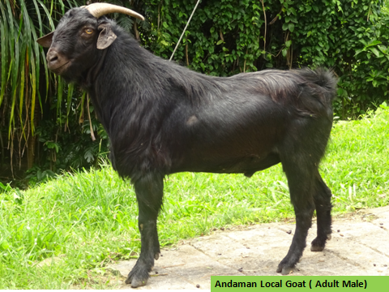
Andaman Local Goats
Majority of goats in these islands resemble Black Bengal and were brought from Bengal and adjacent areas in different phases of inhabitation and rehabilitation of migrated/settled people. These goats are well adapted to the island condition and are widely distributed throughout Andaman Islands. These goats are locally called as Andaman Local Goat. Kidding pattern in these does either prolific, twins or triplets (Table 2).

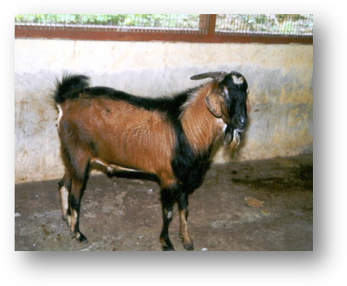
Teressa goat
These are found in Teressa Island and Bambooka Island. Scarce population of these goats is available Nicobar Island, Nancowry Island. However, due to tsunami most of these goats were completely washed out and survey on post tsunami status on population is under progress. These goats generally resemble the Kambing Katchang of Indonesia and tribal community rears them for meat. Age at sexual maturity is about 9 months. Body weight at 4 years is about 60-65 kg. Average milk yield may go up to 1 lit/day. First kidding is 12-13 months (Table 2).

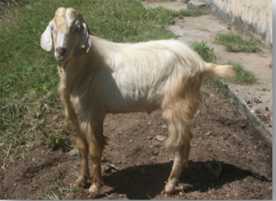
Malabari Goats
This was introduced from Kerala and Tamil Nadu during 7th five-year plan by the Department of Animal Husbandry and Veterinary Services, A&N administration. These goats were mainly introduced for up gradation of indigenous goats.
Barren Islands Goat
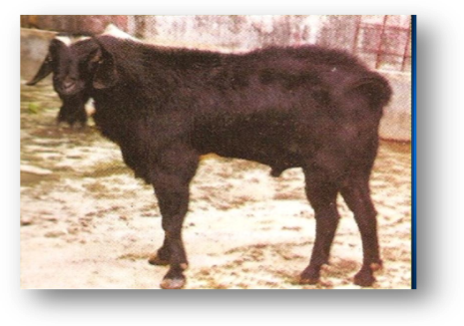
These are feral and semi feral in nature and are available in Barren and Narcondum islands. However, recent volcanic eruption after tsunami (Dec.2004) at Barren Island has created some threat to these goats and post tsunami status of these goats is not known till date. These goats are dependent on seawater. Farm studies showed they prefer 1:4 fresh and seawater for drinking.
Mature body weight is 25-30 kg for males
Table 2 : Production performance
Traits | Teresa goat | Andaman Goat
Birth wt.(Kg) | 1.0-1.5 | 0.7-1.0
No. of kids | 2-4(2.6) | 2.2
Wt. at 1 year(Kg) | 24-26 | 9-11
Wt. at 2 year(Kg) | 35-40 | 12-15
Wt.at 4 year (Kg) | 65-70 | 20-28
Kidding % (in 2 year) | 3.0 | 2.5
Milk yield (Lit.) | 1.2-1.75 | 0.6-0.8
Feeding habits | Feeds on coconut leaves, bakri patti, leaves of bread fruits. | Bakri patti, succulent leaves, of varieties of trees.
Special features | Colour black, brown or white patches on forehead, males have beard, long straight legs, girth is more | Black, brown and admixture of other colour combination, medium sized.
Single (%) | 40.85 | 25
Twins (%) | 53.52 | 75
Triplets (%) | 5.63 | 0

Starting goat farming
Care of purchased animals
Goats purchased should not be taken directly to the farm. Rather, before mingling or newly purchased goats with older stocks, they should be dewormed and dipped in antiparasitic solution. Take special care of lactating doe with kids to avoid environmental stress. The young kids should be protected from possible exposure to extreme cold or heat. B. complex vitamins may be mixed with drinking water to avoid stress. Never allow newly purchased bucks to mix with the old flock directly (Table 3).
Table 3: starting goat farming (20 does + 1 buck)
Particulars of cost | Specification | Cost (Rs)
Night shelters for buck, doe and followers | 10 sq ft/doe and 20 sq ft/buck @ ₹ 140 | 30800
Cost of does (20) | @ ₹ 2000/animal | 40000
Cost of buck (1) | @ ₹ 3500/animal | 3500
Insurance cost | 5% of the total animals | 2175
Equipments (feeder,waterer etc) (5 nos) | @ ₹ 200/equipment | 1000
Fodder cultivation | 1 acre | 3000
Supplementary concentrate feed (one breeding cycle) | 300 g/animal/day ; ₹ 25/kg for 6 month | 29484
Veterinary aid for 21 animals | Lumpsum | 2000
 |  | 111959

Selection of females (Does)
Select young does (good health, large udders and strong legs) carefully to replace old or culled goats. Good appearance of a doe and its performance is often related. It is therefore; sometimes possible to select a good doe by the way they look. Body should be of medium to large size but not obese (fatty) having a wide and deep rib-cage with strong body. A good capacious udder is most important in selecting doe which means good milk producing ability.

Selection of males (Bucks)
A buck can mate 30-35 does. Appearance of a buck is not related to its performance. Strong straight legs and medium to large body are desirable characters in a breeding buck. Analysis of production records (eg., average milk yield for each female, kidding interval, size and weight of kids, multiple births) of buck's mother, daughter or aunts for two to three generations, will reveal breeding potentials of a buck.
Housing for goats
Following are required for a good shelter for goats:
- Construct goat shelter under large trees or near the houses to protect from draught, theft or attack by dogs/ other animals
- Avoid water-logging, marshy areas. In low lying and heavy rainfall areas the floors should be preferably elevated.
- Provide bedding materials (straw, old cloths, dry leaves) to protect goats from cold.
- The shed should be 10 feet high and should have good ventilation.
- Provide good drainage facilities in shelter to prevent illness. For this, floor area can be raised or wooden platform is provided.
- Adult doe requires 2-2.5 m² floor area, whereas buck requires 3 m² floor area. Younger ones require lesser area depending on their size. Does can be housed in groups up to 60 per pen.
- All doorways must be wide enough to pass easily.
- Use cheap, locally available construction materials (bamboo, thatch, coconut leaves etc.) for goat shelter.
- Avoid over stocking or crowding.
Feeds and fodder
Ensure bushes/shrubs for browsing of animals. As an alternative to above, supply of cultivated fodder from own farm or from surrounding farms may be ensured. Offer roughages adlib. As a thumb rule 2/3rd of the energy requirements should be met through roughages. Half of the roughages should be leguminous green fodders and rest half should be grasses/tender tree leaves. In the absence of good quality green fodders, concentrates must be considered to replace them. Kids should be fed colostrums up to 5 days of age. Later on they can be put on kid starter rations (Table 4).
Green leguminous fodders should be offered adlib to kids from 15 days onwards. Provide salt and water to kids at all times. Additional concentrates should be given to bucks and does during breeding season. Care should be taken to meet the nutrient requirements as recommended.
Balanced feeding is the most important factor affecting the weight gain and milk yield of goats. The quality of the feed given is more important than the quantity because goat may not be able to eat enough of low quality feed for its complete nutrient requirement.
A goat has feed conversion efficiency similar to cow i.e., 40%. Breeding bucks need about 0.8 to 1.2 kg of concentrate per day, especially in breeding season.
Table 4: Feeding Schedule for Kids
Age | No. of feeding | Doe's milk | Green feed | Starter feed
1-7 days | With the dam | Ad-lib | - | -
8-42 days | 4 | 100 ml | Ad-lib | Concentrate Ad-lib
43-60 days | 3 | 100mI | -do- | -do-

Type | Dry / Green fodder | Concentrate / Day
Up to weaning (0-60 days) | Ad-lib | -
Yearling doe | -do- | 250 g
Pregnant doe | -do- | 300 – 500 g
Lactating doe | -do- | 150 g for maintenance 400 g for every liters of milk
Breeding buck | -do- | 0.5 to 1.2 kg

Feeding of green fodder
- Because of the specialized browsing ability of the goat, they are able to extract nutrition from the poorest of the wasteland vegetation.
- Area with a lot of bushy plants suits the browsing habits of goats.
- Goat prefers to stand on their hind legs and pluck the tender leafy twigs of herbs, shrubs and small trees.
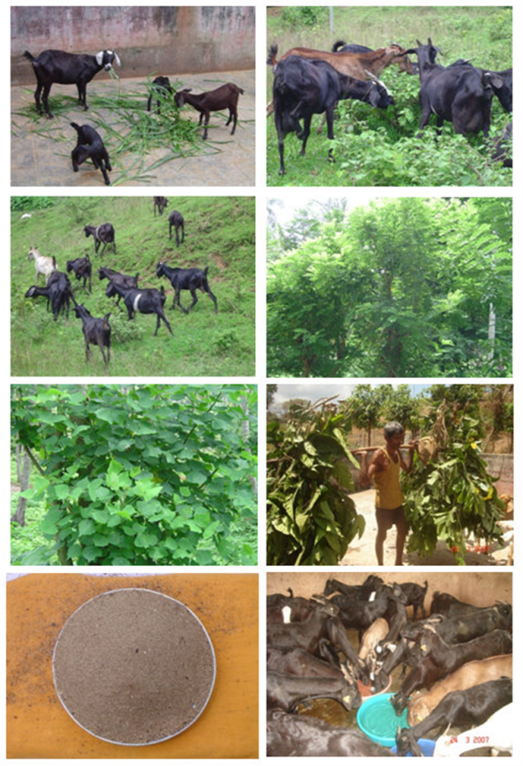
- They like to eat tree leaves.
- They can tolerate even bitter taste but hesitate to eat a wet, sticky, spoiled feed or fodder.
- Goats can digest tough plant materials better than cattle.
- Mixed grazing of cattle and goats together can help prevent the pastureland turning into bush land.
- Legume trees such as Acacia and Leucaena can be planted as fencing around farmer's farm I house which can serve as a good fodder source for goats.
- When goats are allowed on pasture land care is to be taken so that at any one time goats should not have access to more than one-third of the land available, otherwise indiscriminate grazing by goats will result in under-development of growing shoots of pasture grasses.
- Pastureland can also be developed for commercial goat grazing.

Some suitable green available for goats are -
Tree leaves: Neem, Peepal, Jamun, Ber, Glyricidia, Erithrina and Bamboo leaves
Cultivated pasture grasses: Siratro, Stylosanthes, Desmodium and Clover.
Straw: Paddy straw, Arthar straw etc.

Important points about breeding/pregnancy
- It should be planned to obtain 3 kidding in 2 years period by adopting optimal management conditions.
- For every 25 does, one buck should be provided in one breeding season.
Breed the animals 12 hours after the onset of the first symptoms of heat for maximum conception.
- Separate young goats (male and female), from four months of age to prevent premature breeding.
- Animals are to be bred at the age of 8-9 months for maximum productivity.
- Cull the old animals at the age of 6 years and above.
- Avoid the kidding during peak periods of summer and winter.
- First heat of doe occurs at 6 - 8 months of age. Some may show heat by 3rd month, however avoid breeding until they are fully-grown.
- Adult doe comes to heat once in every three weeks, and heat lasts for one to three days.
- Duration of pregnancy is 145 to 155 days (approximately five months).
- Maintain breeding records to identify appropriate time of kidding.
- In advanced stage of pregnancy the does must be transferred to either kidding pens or separately earmarked space for kidding within the main shed after thoroughly disinfecting it. After kidding, the does should be provided with warm bran mash for two days.

Care of Neonates & kids
- Clean the mouth and nostrils of the new born kid, wipe with a clean cloth to clear the sticky mucous. This facilitates breathing of the kid.
- In case kid finds it difficult to breathe or breathing is noisy, then hold the hind legs of the kid in both hands and give a swing to the kid to expel out mucous.
- Knot the broken umbilical cord of the kid and apply Tincture Iodine or antiseptic solution to the stump to prevent spread of the infection.
- Encourage the kid to suckle the doe's teat for colostrum feeding within two hours of the birth. Colostrum contains immunological substance, which helps the kid in fighting various diseases.
- Completely separate the kids from the doe at 12 to 16 weeks of age (three to four months), depending on the body growth. At this time, completely stop the milk feeding.
- Provide small quantity of concentrate (0.25 kg per day) to kids of four to six weeks onwards, for faster growth.
- Kids, for at least first two months, require special housing provisions to protect them from inclement weather.
- Males are castrated at varied ages (usually 3-4 months). Castration reduces buck odour in meat. Castration improves body growth. It improves lean production by reducing bone percentage in the carcass.
Common illness in Goats and Health Care
Productivity of goat is dependent on the health it keeps. A goat farmer needs to know the health signs, the symptoms of common illness and what he can do at his level. (Table 5).
Table 5: Common diseases and treatment of goats
Diseases | Symptom | Treatment and care
Foot rot | Lameness/limping, smell from affected foot | Foot bath with copper sulphate, chlorine, 10 % formaline. Regularly trim hoof
Internal parasite | Loss of weight, starved appearance, less milk production, ruffled hair and coat, diarrhoea is often present, anaemia | Regular deworming
External parasites | Goats will scratch a lot, general restlessness, loss of weight, frequent loss of hair, decreased milk production. | Apply neem oil, dipping, and regular deworming.
Udder infection  (mastitis) | Udder is swollen, lumpy and painful, dissimilarity of both quarters, loss of milk production., milk is salty in taste, milk with cheesy flakes / clots, colour of milk reddish, brown or yellow with pus | Keep the udder clean and dry, and milk the goat in a clean and dry place, milker should trim his nails, hands washed before milking and should be free from infectious diseases, Keep flies away, especially during milking, form goats.
Poisoning | Appears suddenly in most of the cases, excited or unsteady movement of the goat. Goat may become dull and unconscious, Convulsions and eventual death may ensue, Severe pain, vomiting and fluid faeces. | Drench the goats with salty water to make them thirsty, Chalk powder mixed with burnt bread or catachue can be administered to slow-down the absorption of poison from the stomach.
Bloat | Stomach is swollen greatly, goat does not eat grass and appears restless, difficult breathing; death may ensue in absence of proper treatment. | Force the goat to drink 100 ml of groundnut oil, liquid paraffin. Do not allow goat to eat too much of fresh leguminous grasses, Provide high fiber diet (straw or hay) before allowing onto new grazing land, in severe eases.

